**CMP1902M Object Oriented Programming 2022/23**

**Assignment 1: Report**

[*Expand the sections as necessary*]

Name: Milo Bragaloni

Student ID: 26595773

Git/Version Control Repo: TBD

**Code Review**

1. **Who did you provide reviews for?** *(Name, Student ID)*

*Oliver Smith (26357261)*

Archie(TBD)

1. **Who provided reviews for you?** *(Name, Student ID)*

Oliver Smith (26357261)

Archie(TBD)

1. **Reflection on code review: What did you consider changing / changed after receiving the reviews?** *(~400 words)*

*The reviews I’ve received helped me detect a lot of the direct sources of issues I was having with the code that I couldn’t find the solutions to without. On top of that it inspired me to push onward and eventually add more functions than I had before receiving the reviews.*

1. **Include evidence of the reviews *(screenshots are OK)***

**Reviews of my Code:**

* **Oliver Smith:**
* Immagine che contiene testo

  Descrizione generata automaticamente

**My reviews of other’s code:**

* **Oliver Smith:**
* 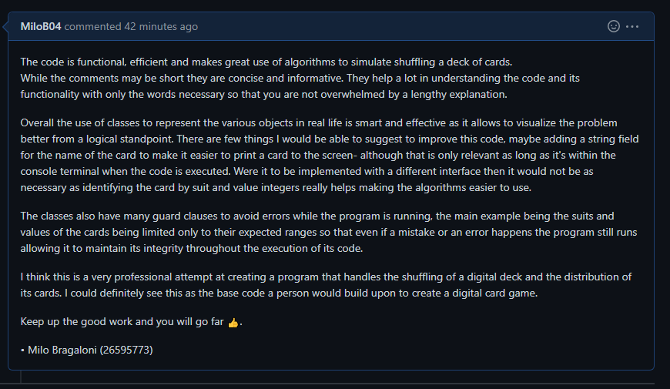
* **Archie (TBD)**
* Immagine che contiene testo

  Descrizione generata automaticamente

**Reflection and Feedback**

1. **What was the most important thing you learned from this assessment?** *(< 200 words)*

I’ve learned that sometimes having a new set of eyes look at the same problem unclouded by the previous work done on it can help shed light from a new perspective to what once seemed an unsurmountable obstacle. Working with the help of others Is key to surpass my own limitations as a person and I should become more comfortable doing it more.

1. **What was the most challenging aspect of this assessment and how did you approach it?** *(<200 words)*

The most challenging part of this assignment was working on the code all the way up before the code review. For some reason I became stubborn and convinced myself that I’d make a working prototype before putting it up for reviews, but it ended up being much further than the truth.

I tunnel visioned too much on one aspect of the assignment without realizing the importance of the reviews themselves as a tool to make my own life easier.

1. **What would you particularly like to receive feedback on in this assessment?**

I think it would be helpful to know how I could have made the code simpler and more efficient. I ran into a lot of issues that I solved, but in the process, I ended up making the functions overly complex.

**Assignment 1: Checklist**

All of the elements in a section must be checked for it to be considered for that grade (this isn’t guaranteed though). All previous elements must also be complete for a grade to be considered.

Pass standard:

|  |  |
| --- | --- |
| Received two code reviews. | X |
| Made two code reviews. | X |
| Addressed **at least two** of the questions in each of your reviews. (*1. How is the code documentation, 2. How does the code handle errors, 3. How can the code be improved*) | X |
| The code compiles and runs | X |
| The classes provided by the base code are implemented | X |
| The methods provided by the base code are implemented | X |
| Object instantiation and method calls used in the code. | X |
|  |  |

2:2 standard:

|  |  |
| --- | --- |
| Addressed the **three** questions in each of your reviews. | X |
| There is a short description of the code review process. | X |
| The code compiles and runs | X |
| Some evidence of error handling | X |
|  |  |
|  |  |
|  |  |
|  |  |

2:1 standard:

|  |  |
| --- | --- |
| The code compiles and runs | X |
| No errors evident | X |
| A Test class is used | X |
| There is a description of the code review process | X |
| **Additional** methods to those provided by the base code are implemented – point out with comments | X |
|  |  |
|  |  |
|  |  |

First standard:

|  |  |
| --- | --- |
| Error handling, either by exception handling or other methods is complete and no errors are produced. | X |
| Encapsulation an/or Abstraction are used in the code and identified. |  |
| **Additional** classes to those provided by the base code are implemented – point out with comments | X |
|  |  |
|  |  |
|  |  |
|  |  |
|  |  |